Assignment – 1

• Install Power BI Desktop and share the final screenshot of the report view page which appears when power desktop starts

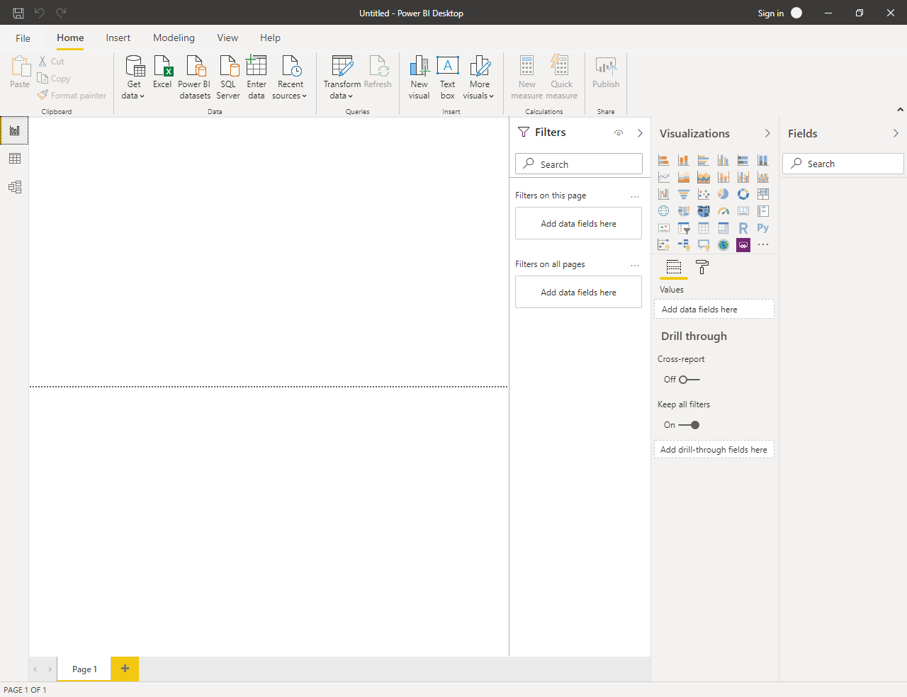

• Report View



• Data View

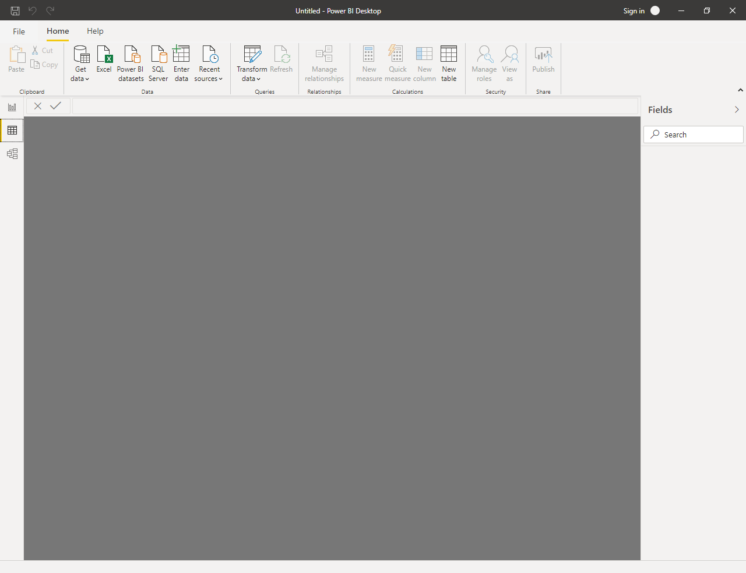

Model View:

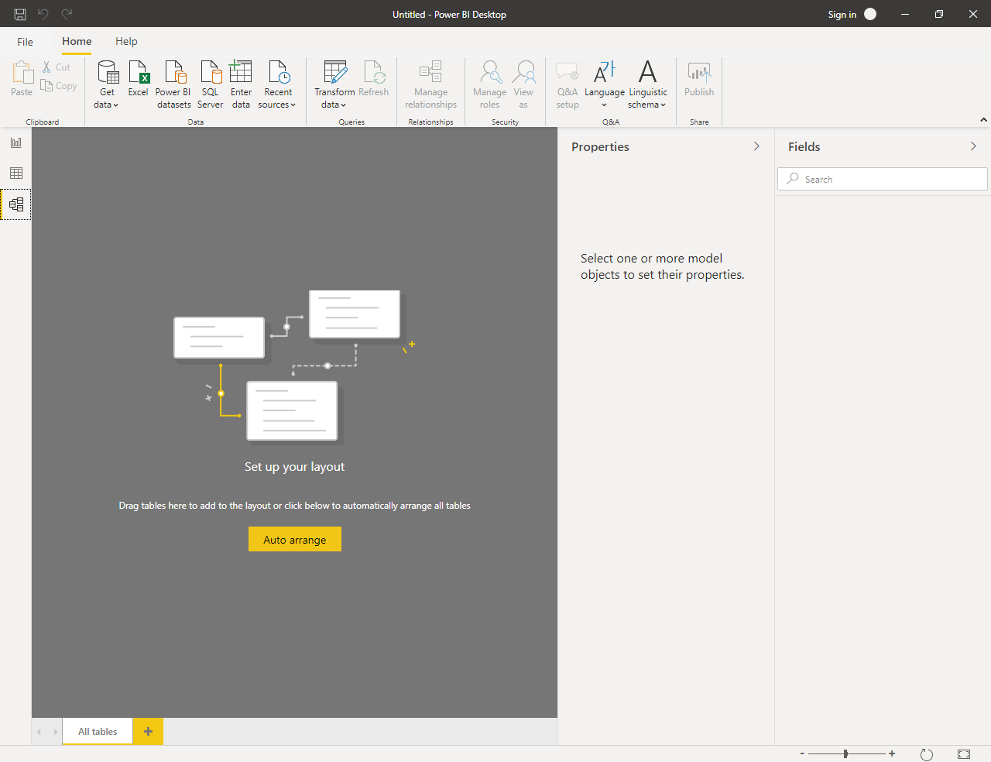

• Power Query Editor

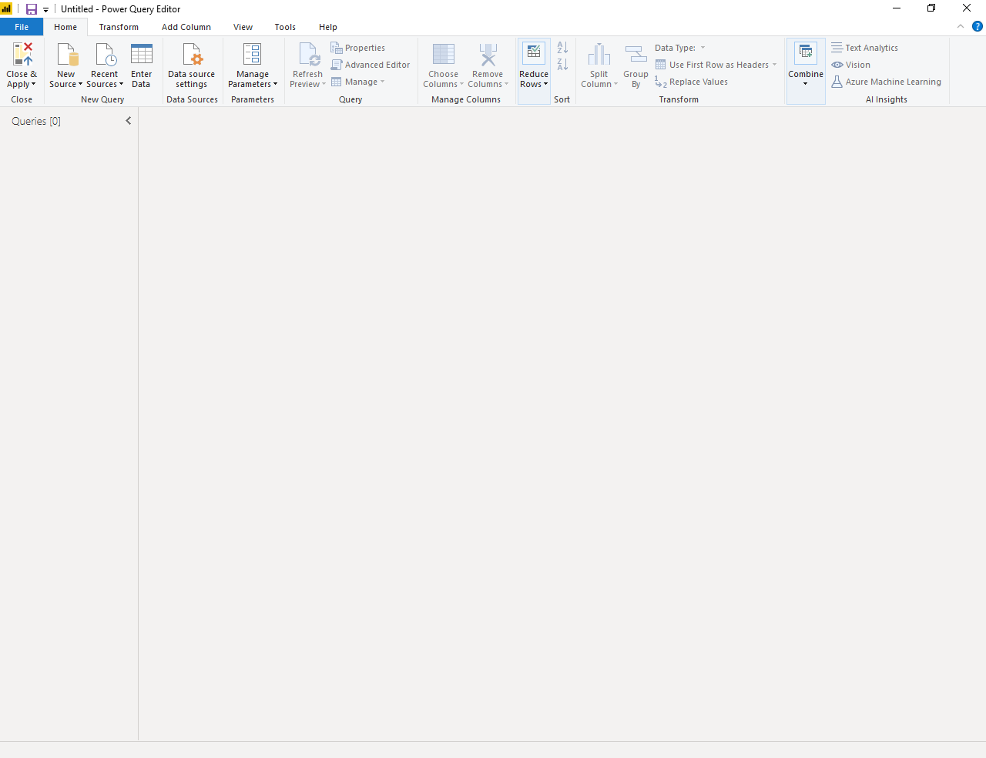

• Advance Editor

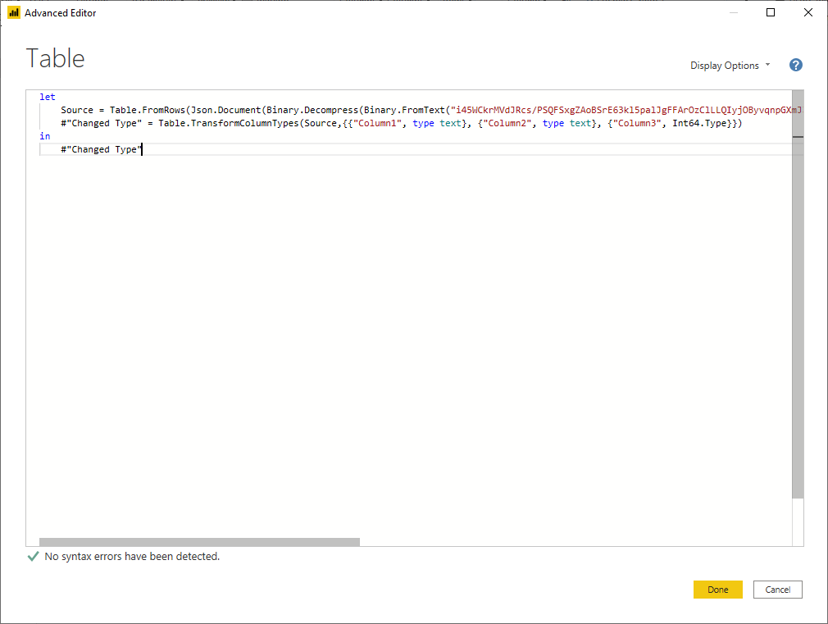

• Prepare a document with details of the following along with their price

Power BI Desktop is free and below screenshot shows the pricing information for Pro and Premium

